CSA1704-ARTIFICAL INTELLIGENCE LAB
5. Write the python program for Missionaries Cannibal problem
AIM
To write a Python program to solve the Missionaries and Cannibals problem using the Breadth-First Search (BFS) algorithm.

Objective

To implement the BFS search algorithm in Python to safely transport three missionaries and three cannibals from the left bank to the right bank of a river without allowing cannibals to outnumber missionaries on either bank.

Algorithm
• Define the initial state and goal state of the problem.
• Represent the state using the number of missionaries, cannibals and boat position.
• Place the initial state into a queue.
• Remove the first state from the queue.
• Check whether the current state is the goal state.
• If it is the goal state, display the solution and stop.
• Otherwise, generate all possible boat movements:
- One missionary
- One cannibal
- Two missionaries
- Two cannibals
- One missionary and one cannibal
• Check whether the new state is valid.
• Add the new unvisited states to the queue.
• Repeat Steps 4–9 until the goal state is found.
• End the program.

Flowchart
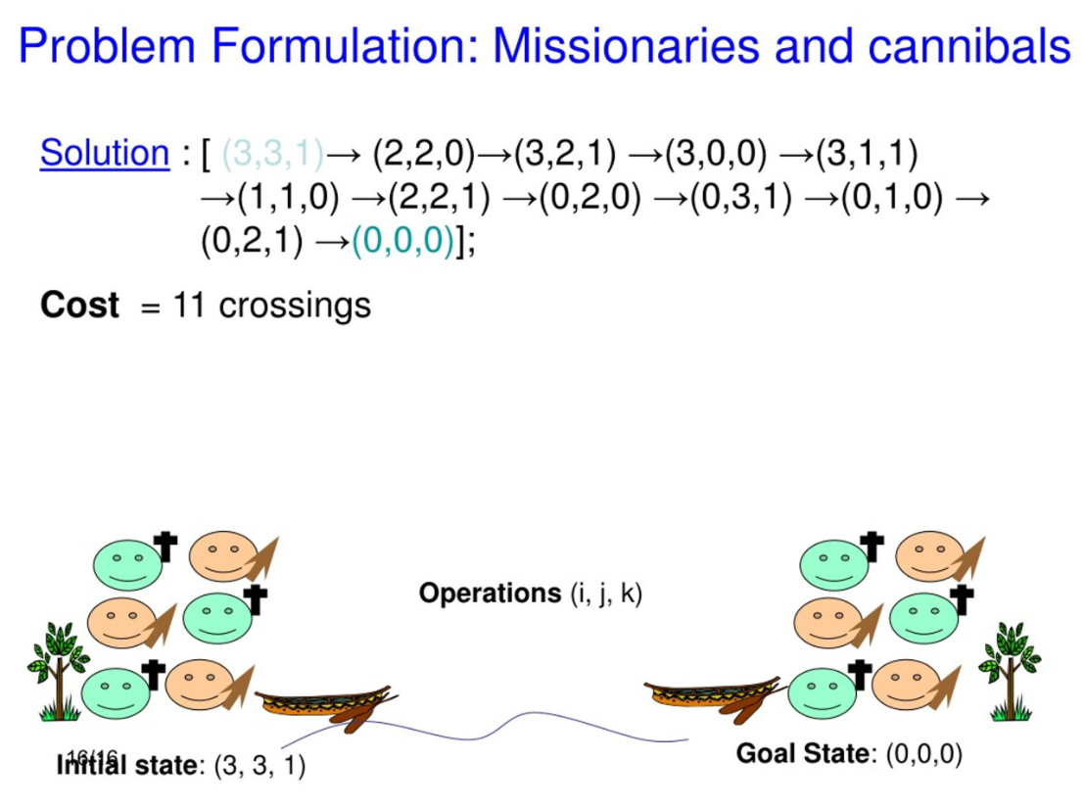

Code

from collections import deque

start = (3, 3, 0)

goal = (0, 0, 1)

moves = [(1,0), (0,1), (2,0), (0,2), (1,1)]

def valid(m, c):

if m < 0 or c < 0 or m > 3 or c > 3:

return False

if m > 0 and m < c:

return False

rm = 3 - m

rc = 3 - c

if rm > 0 and rm < rc:

return False

return True

queue = deque([(start, [start])])

visited = set()

while queue:

state, path = queue.popleft()

if state == goal:

print("Goal Reached!\n")

for step in path:

print(step)

break

if state in visited:

continue

visited.add(state)

m, c, boat = state

for dm, dc in moves:

if boat == 0:

new_state = (m-dm, c-dc, 1)

else:

new_state = (m+dm, c+dc, 0)

if valid(new_state[0], new_state[1]):

if new_state not in visited:

queue.append((new_state, path + [new_state]))

OUTPUT

Goal Reached!

(3, 3, 0)
(3, 1, 1)
(3, 2, 0)
(3, 0, 1)
(3, 1, 0)
(1, 1, 1)
(2, 2, 0)
(0, 2, 1)
(0, 3, 0)
(0, 1, 1)
(0, 2, 0)
(0, 0, 1)

RESULT:
The Python program successfully solved the Missionaries and Cannibals problem using the Breadth-First Search (BFS) algorithm and safely transported all missionaries and cannibals to the right bank.

CONCLUSION
The Missionaries and Cannibals problem was successfully solved using the BFS algorithm in Python. The program explored the possible states and found a valid sequence of movements while following the safety conditions. This demonstrates the application of AI search techniques in problem solving.

